What is the language of art and how can it be used?
In today’s world it is not easy to pin down the concepts of art (often referred to as the visual arts).

A brief background:
In the mid-1800s, when art education was just getting started, art was easy to define. It was painting, sculpture, and architecture made in the Western tradition. Beginning around the turn of the century things began to change because concepts of what was art began to include: (1) the acceptance of crafts as art, and (2) the acceptance of non-western objects of art. In particular, Japanese wood-block prints and African sculpture, and (3) the modern art movement (Teaching Children Art, 1997).

In the late 1800s the arts and crafts movement revived the hand crafting of objects like furniture and pottery in protest to the mass-produced products of the industrial age. In addition, the new sciences of archeology and anthropology stimulate an interest in tribal objects such as mask, cult images and even tools and weapons. Eventually, these artifacts came to be appreciated as art. Today every major art museum (including the Turner Center) has a significant collection of well-designed utilitarian objects and non-Western art from a variety of times and places (Teaching Children Art, 1997).

In the early 1900s modern art not only challenged realistic art but introduced news ways of thinking and making art. New materials and art-making process from new and emerging technologies, such as photography and computer art, emerged into the art world (Teaching Children Art, 1997).

Visual arts today are incredibly diverse and the past definitions are constantly being redefined as the world and concepts around us are redefined.

For this purpose, the following are the Elements and Principles. Handouts are provided regarding definitions.
Elements of Art: line, shape, form, texture, value, color and space
Principles of Design: balance, emphasis, movement, pattern, rhythm, unity, contrast

To help establish the Elements and Principals in any given piece of artwork exploratory questions can be asked of the viewer. Edmund Burke Feldman developed four steps that can be used to engage the viewer when looking at any given piece of artwork. The official list is below. The steps have been adapt to reflect what is being done at the Turner Center. The fourth step has been eliminated. The audiences for the tours will be middle level and secondary students.
A. Edmund Burke Feldman’s Aesthetic Criticism (as set out in Varieties of Visual Experience by Feldman)
Questions:
1. Description – identifying what can be seen: elements and materials – describe the visual and literal qualities. Art Historically deals with where, who and when. Be objective.
2. Formal Analysis- how is this put together physically and compositionally and identifying style or subject matter. What relationships do the elements sustain?
3. Interpretation – Why did the artists make the choices he did about materials, composition, subject matter, etc.? What is the artist trying to say? Is there an emotional tone?
4. Evaluation/Judgment – How does this compare with similar works? Did the artist make the right decisions? Does the work say what he wanted to say? Is the work of high quality? What do you think the artist could improve on? Does the work communicate significant ideas or arouse emotions? Etc.

My application of Feldman’s work:
When presenting artwork to most people the first three steps of Feldman’s model will be used.

Description – What do you SEE?
Carefully view the selected artwork and give a detailed answer to the question, “What do you see?” Identify only what can be seen in the work including the elements of art and materials used. Be very literal. There will be many answers to this question so be prepared to interject one or more answers if needed to prompt the conversation – make a list. Use questions like, “What do you see in the artwork?” And, “What else?”

Look at the artwork from various points of view trying to understand the mind-set of the group to be engaged in the discussion. Include the content of the artwork and the subject matter in representational works and include abstract elements in nonrepresentational works such as “What draws you in?”

Know the basic background of the piece(s) such as the name of the artist and any personal information that might be available. Know the medium (media) and the style. Keep the information interesting and aimed at the age level of the group.

Formal Analysis – What do you THINK?
Formal Analysis- how is this put together physically and compositionally and what is the identifying style or subject matter? What relationships do the elements sustain?
Next, examine the artwork for Principles of Design. Compare the terms to the artwork and find at least one Principle that obviously pertains to the artwork. Words such as exaggeration and composition can be used at this point. The Principles of Design are more abstract in concept than the Elements. More complex questions can be asked at this point such as:
- How do the various sections of the piece work together?
- Do the pieces contrast with each other?
- How does the artist create interest?
- What part does color play? (Or use any other obvious Elements.) If students get the easy ones then dig a little deeper for more insightful comments.

Interpretation – What do you SENSE?
Why did the artist make the choices he/she did about materials, composition, subject matter, etc.? What is the artist trying to say? Is there an emotional tone?

Examine the artwork carefully acquiring a personal interpretation answering questions such as:
- How does the work make you feel?
- What do you think it means?
- What was the artist trying to communicate? Be sure to list the information in the painting that backs up those feeling or ideas.
- What clues do you see that support your ideas?
Here, use the artwork to tell some sort of story. It could be conflict, or nature, or questioning society. Whatever the feeling, it must be backed-up with visual statements made in the painting.

The following information from Museum-Ed presents questions used to address Feldman’s steps. Similar questions could be used when discussing works of art with students.
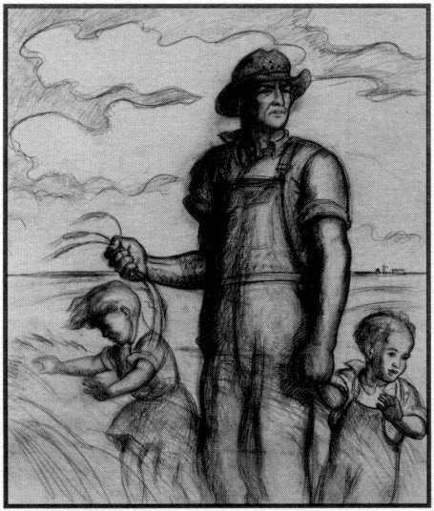
Try answering the following questions using this lithograph by John Steuart Curry, entitled “Our Good Earth” around 1942, BMA 1992.123
Description (SEE) – identifying what can be seen: elements and materials – describe the visual and literal qualities. Art Historically deals with where, who and when. Be objective.
Name and describe what you see – objects, spaces etc.
Materials – what is this made out of? How is it made?
Classify the elements – lines, shapes, textures.
Formal Analysis (THINK) - how is this put together physically and compositionally and identifying style or subject matter? What relationships do the elements sustain?
Find examples of repetition, rhythm, etc.
Where is the focus and how is it achieved?
What kind of spatial devices are used to create dimensionality?
What is the relationship of the figures to each other?
Interpretation (SENSE) – Why did the artists make the choices he did about materials, composition, subject matter, etc.? What is he/she trying to say? Is there an emotional tone
What is going on in the painting?
Is there a possible theme?
How do the parts of the painting contribute to this theme? Is there any symbolism?
When do you think this was painted and why?
Is the work in an identifiable style?

