Alfred Phillips Biography and Artist Statement
(view on Turner Center’s website)
Biography
Alfred Phillips is a Gainesville-based artist who specializes in acrylic painting. Educated at Louisville, Kentucky’s Art Center School, Phillips had a long, successful career in commercial art that included stints at ad agencies, then at his own graphic design firm. In 2003 he closed the firm and took up art full time when he relocated to Fort Lauderdale, where he spent a decade racking up countless awards, including more than a dozen Best in Show designations and sales on national and international levels. His work can be viewed at Rossetti Fine Art Gallery in Fort Lauderdale, FL and Patent-Arts Gallery in Gainesville, FL.

Artist Statement (which includes his style of work)
“Because I always paint realistically but never to the point of photorealism, I call my work ‘contemporary realism’, and it often has a narrative theme. I will sometimes incorporate almost abstract-like areas, with drips and splatters, and shapes and angles, even in my most detailed paintings. Then I might focus extreme detail in certain area of the canvas to draw the eye and bring the viewer closer to the painting.”
(Photorealism & Abstract-like areas will need to be explained; websites/images are linked; website for Ozeri is not student-friendly – only view the individual artworks.)
Photorealism

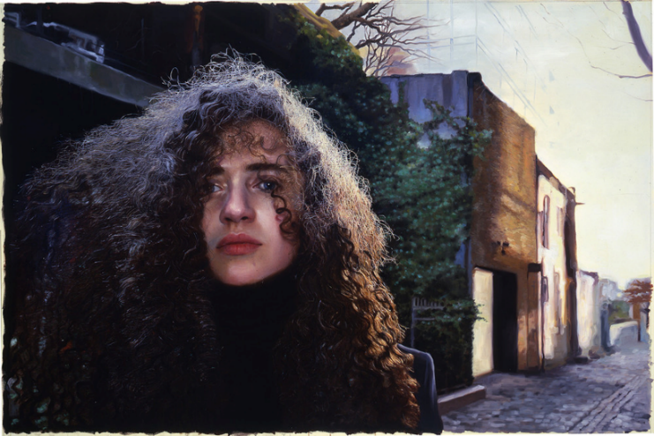
Abstract-like

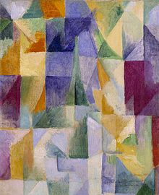

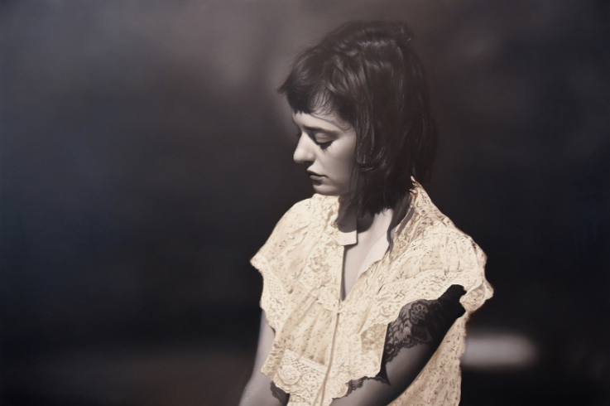
Yigal Ozeri Untitled; Olya Monochrome 2015

Yigal Ozeri Sasha in the West Village 2005
Robert Delaunay, 1912, Windows Open Simultaneously (First Part, Third Motif), oil on canvas, 45.7 x 37.5 cm, Tate Modern

